Name: Akshat Bhargava
Rollno: BEAD-22563
DMV Practical 9
Problem Statement: Data Wrangling on Real Estate Market

1. Import the "RealEstate_Prices.csv" dataset. Clean column names by removing
spaces,special characters, or renaming them for clarity.
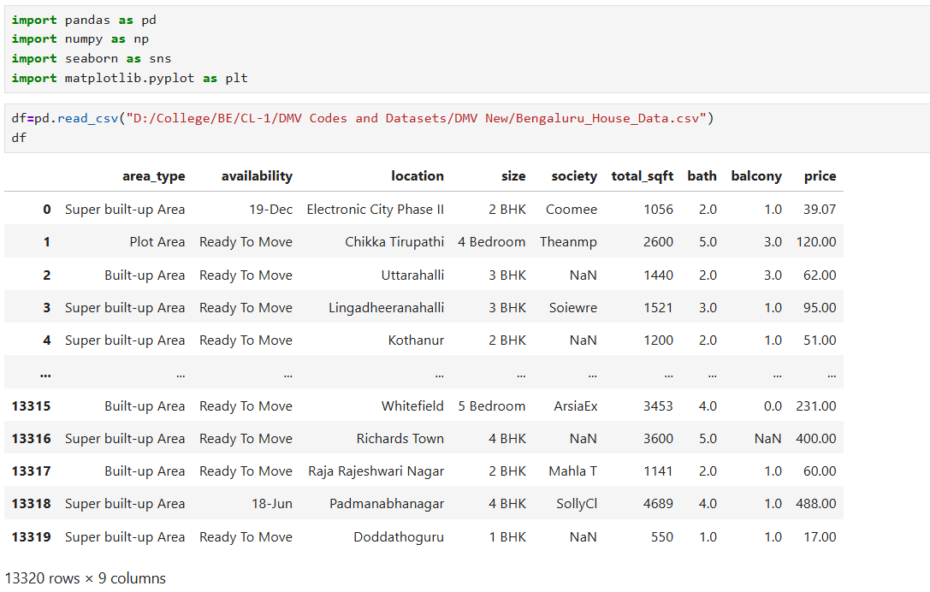
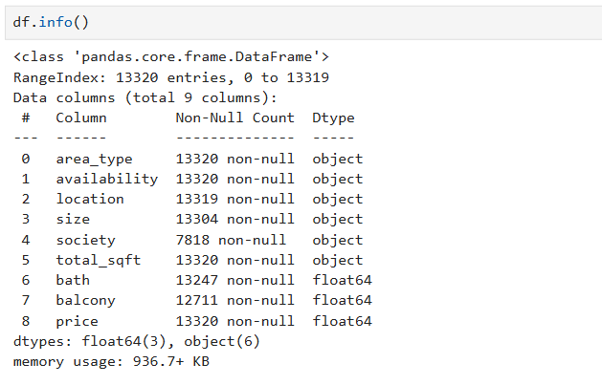

2. Handle missing values in the dataset, Filter and subset the data based on specific criteria, such as a particular time period,property type, or location.
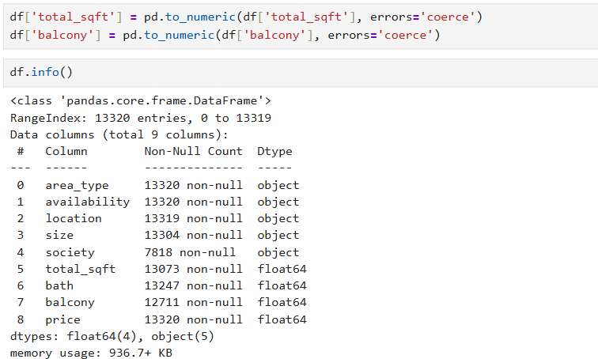
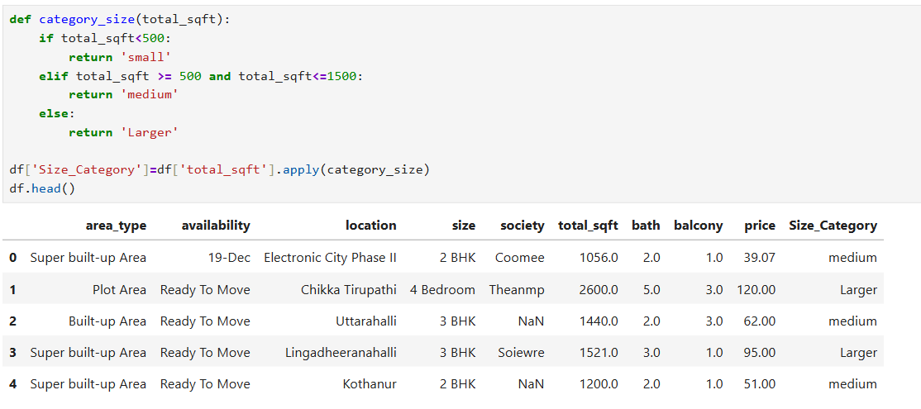
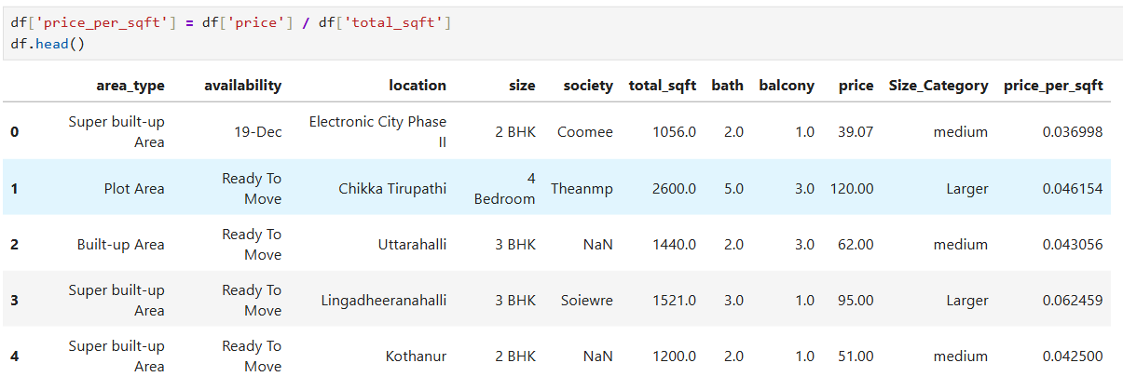
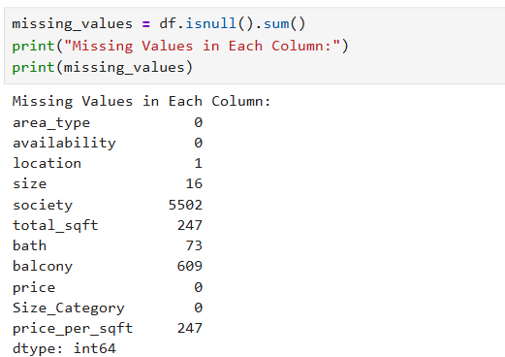
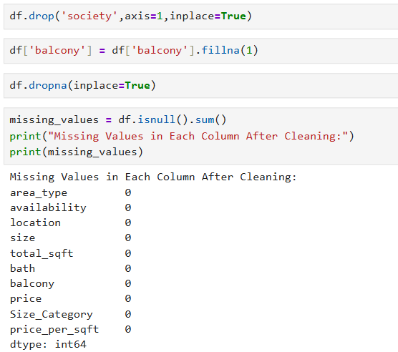
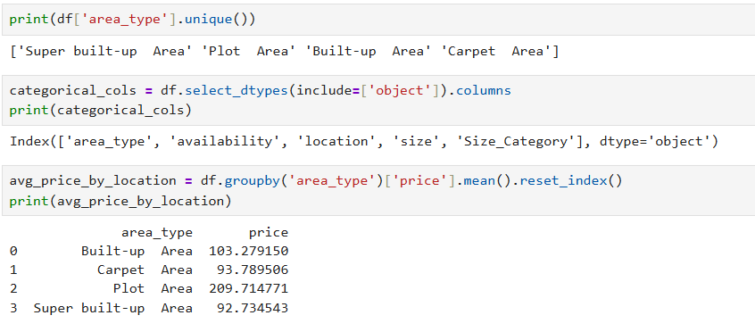

3. Handle categorical variables by encoding them appropriately (e.g., one-hot
encoding or label encoding) for further analysis.
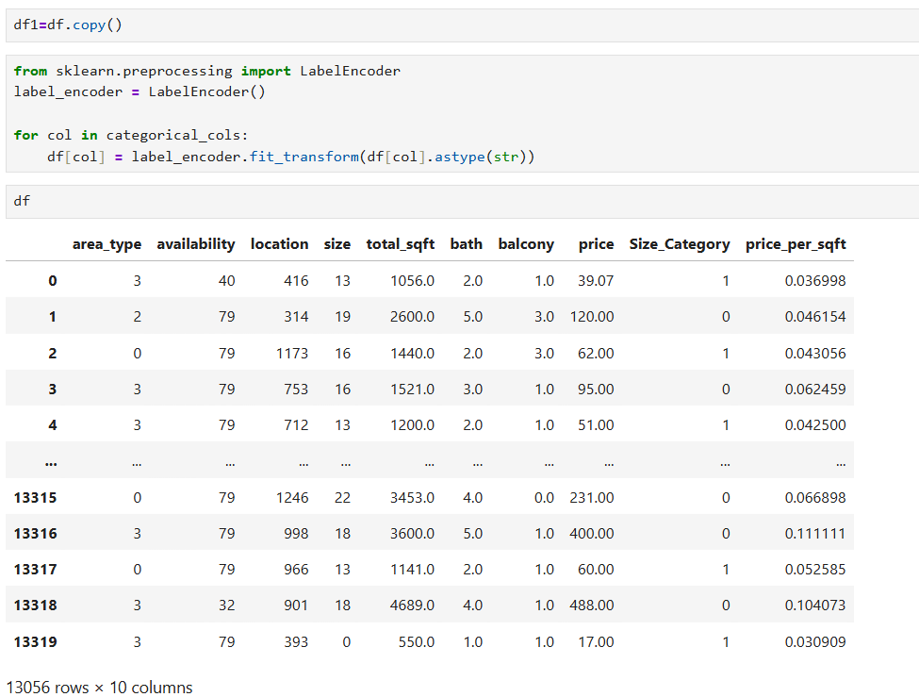
4. Aggregate the data to calculate summary statistics or derived metrics such as
Average sale prices by neighborhood or property type.
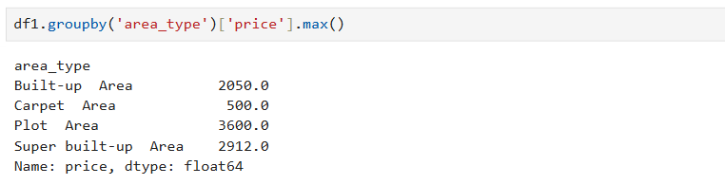
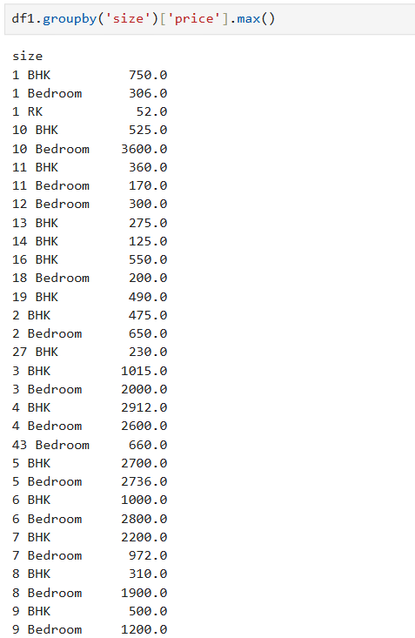
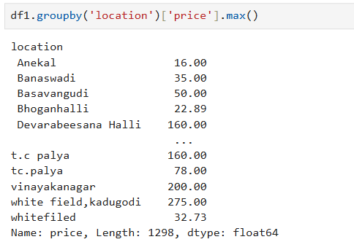

5. Identify and handle outliers or extreme values in the data that may affect the analysis or modeling process
